**POST (all the 10 entries):**

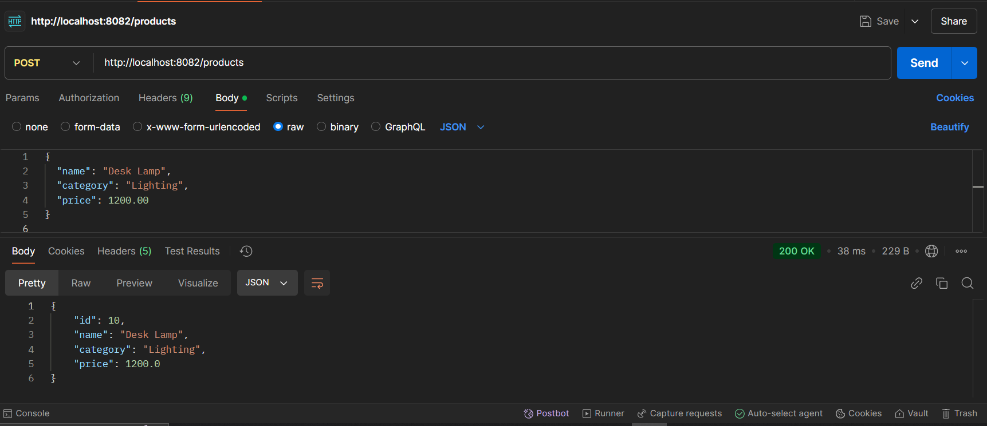

**GET (displaying all the 10 data):**

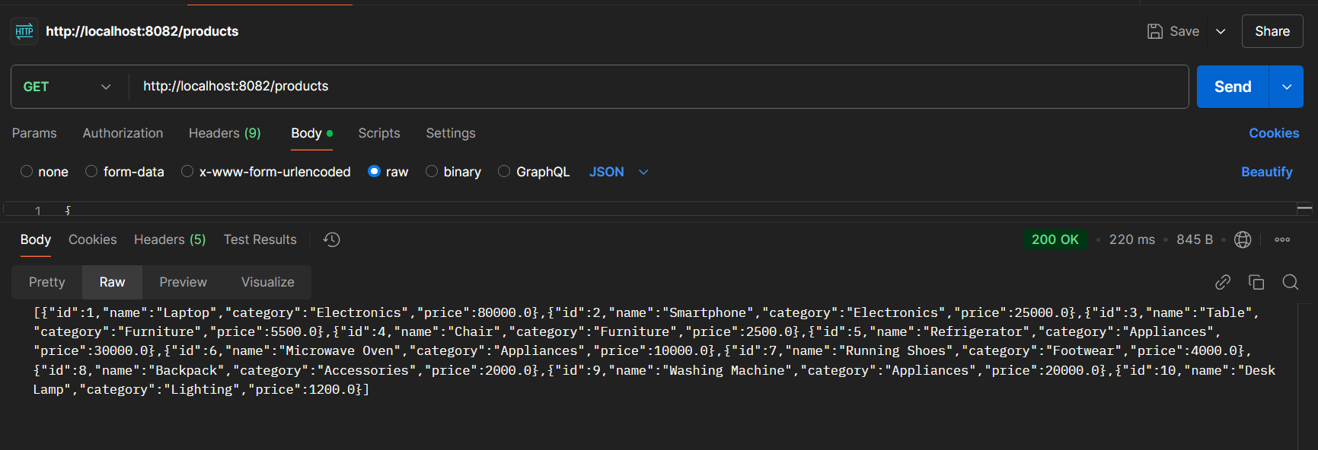

**Showing the MySQL database and the product entries using POST:**

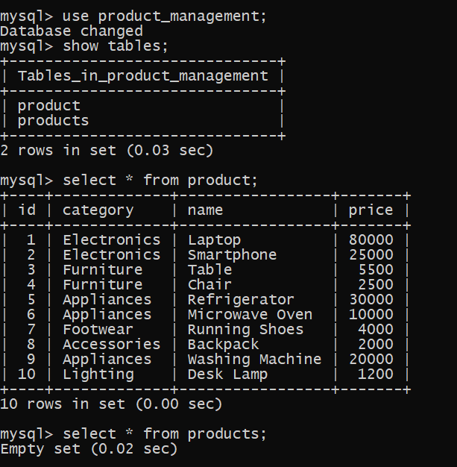

**PUT (updating the name of the laptop):**

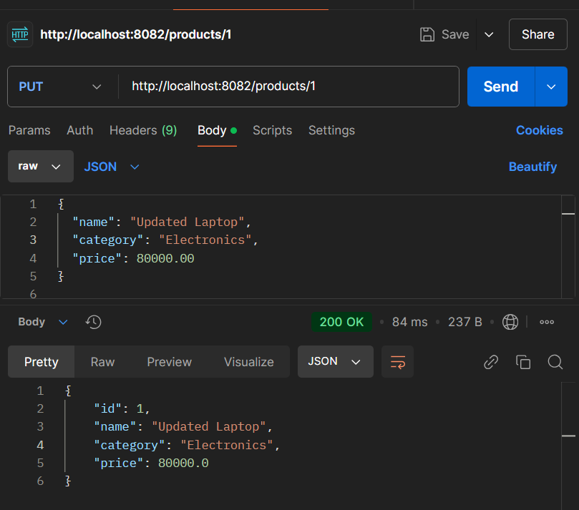

**DELETE (using a particular id):**

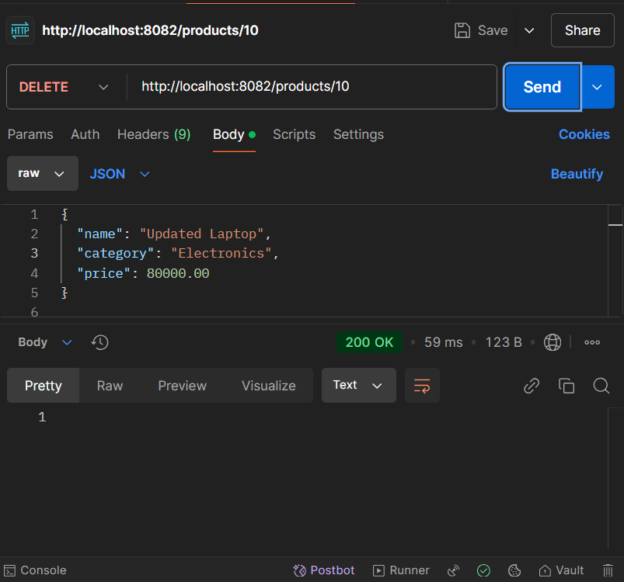

**GET (to show the deleted id from the database):**

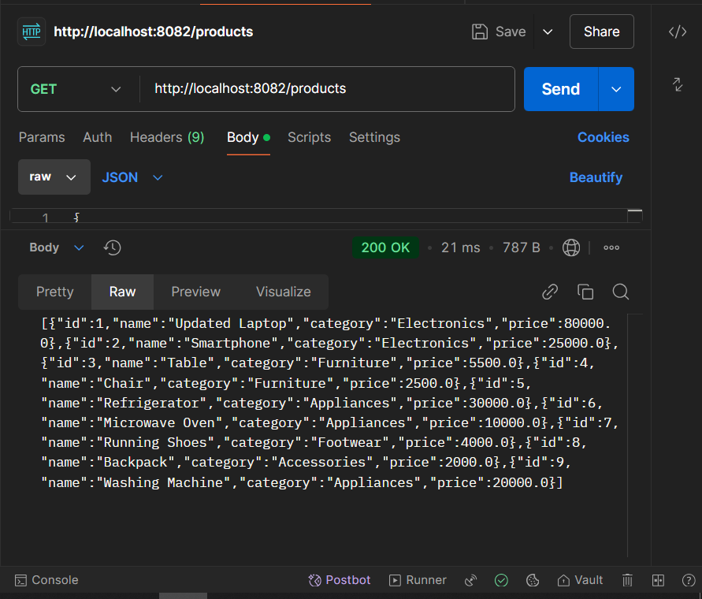

**PUT & DELETE reflected in database:**

